**AWS CI-CD Pipeline**

**IAM ROLE**

An **IAM Role** is a set of permissions in AWS that **an entity (like a user, service, or application)** can assume temporarily to perform actions on AWS services.

Unlike an IAM **user**, an IAM **role** has **no credentials** (like passwords or access keys). Instead, **other AWS services or trusted users assume the role** to gain the permissions attached to it.

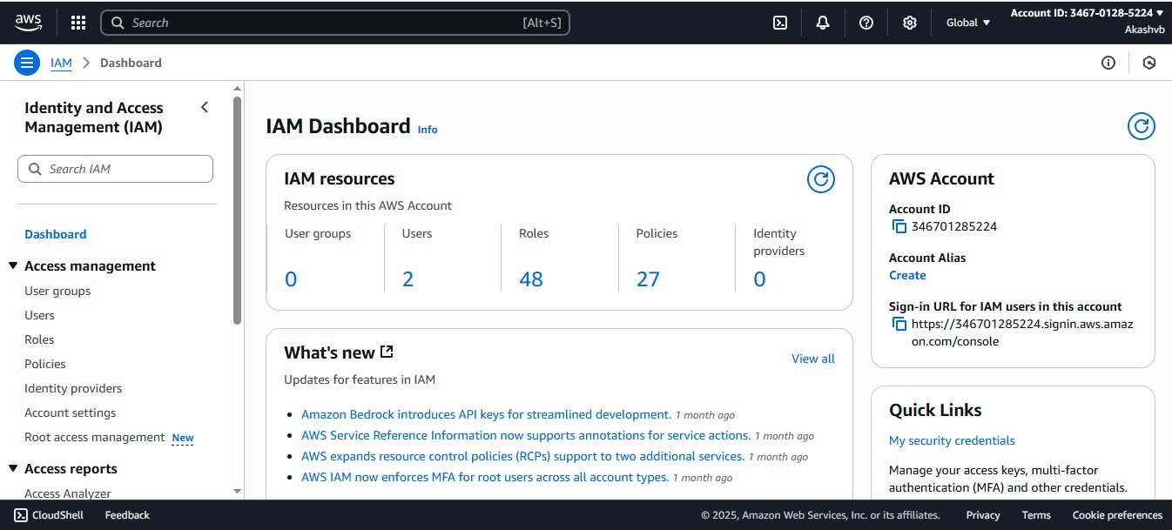

**AWS EKS**

## **☸️ What is Amazon EKS?**

**Amazon EKS (Elastic Kubernetes Service) is a fully managed Kubernetes service that makes it easy to run Kubernetes on AWS without managing your own control plane (master nodes).**

## **✅ Prerequisites**

**Before creating an EKS cluster, make sure the following are installed:**

| **Tool** | **Purpose** | **Command to Check** |
| --- | --- | --- |
| **AWS CLI** | **To interact with AWS** | **aws --version** |
| **kubectl** | **To manage Kubernetes cluster** | **kubectl version --client** |
| **eksctl** | **Simplifies EKS setup** | **eksctl version** |
| **IAM Role** | **To allow EKS to manage AWS resources** | **Created during setup** |

**✅ Tip: If you're missing any of the tools, you can install them via the official AWS docs or I can guide you.**

## **🏗️ Step-by-Step: Create EKS Cluster Using eksctl**

### **🔹 Step 1: Configure AWS CLI (if not already)**

**aws configure**

**Enter:**

* **AWS Access Key ID**
* **Secret Access Key**
* **Region (e.g., ap-south-1)**
* **Output format (optional)**

### **🔹 Step 2: Create EKS Cluster + Node Group**

**Run the following command:**

**eksctl create cluster \**

**--name brain-tasks-cluster \**

**--region ap-south-1 \**

**--nodegroup-name brain-tasks-nodes \**

**--node-type t3.medium \**

**--nodes 2 \**

**--nodes-min 1 \**

**--nodes-max 3 \**

**--managed**

* **Configure kubectl context**

### **🔹 Step 3: Verify Cluster Is Ready**

**kubectl get nodes**

**You should see a list of nodes in Ready state.**

### **🔹 Step 4: Deploy App (Optional)**

**Now that the EKS cluster is running, you can deploy your app using Kubernetes manifests:**

**kubectl apply -f deployment.yaml**

**kubectl apply -f service.yaml**

## **🔄 To Delete EKS Cluster (To Avoid Charges)**

**eksctl delete cluster --name brain-tasks-cluster --region ap-south-1**

## **📌 EKS IAM Role Policies (Behind the Scenes)**

**When creating an EKS cluster, eksctl automatically creates IAM roles with the following managed policies:**

* **AmazonEKSClusterPolicy – Allows EKS control plane access**
* **AmazonEKSWorkerNodePolicy – Allows nodes to join cluster**
* **AmazonEC2ContainerRegistryReadOnly – Access Docker images from ECR**
* **AmazonEKS_CNI_Policy – Required for networking in the cluster**

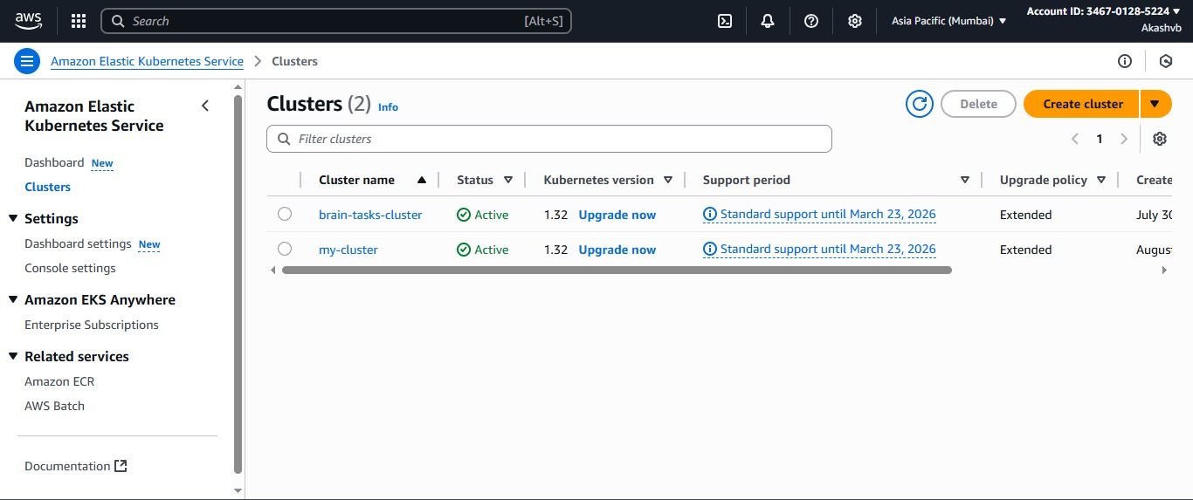

**AWS ECR**

AWS ECR-Images

Great! Let’s go step by step on **how to create and use AWS ECR (Elastic Container Registry)** — which is used to **store your Docker images** before deploying them to EKS, ECS, or other services.

## **📦 What is Amazon ECR?**

**Amazon ECR (Elastic Container Registry)** is a **fully managed Docker container registry** that lets you **store, manage, and deploy Docker container images** securely on AWS.

## **✅ Why Use ECR?**

* Secure, private Docker image storage
* Integrates with **CodeBuild**, **EKS**, **ECS**
* Highly available and scalable
* No need to manage your own registry

## **🛠️ How to Create and Use an ECR Repository (Step-by-Step)**

### **🔹 Step 1: Create an ECR Repository**

Use the AWS CLI:

aws ecr create-repository \

--repository-name brain-tasks-app \

--region ap-south-1

Output will include a repository URI like:

<your-account-id>.dkr.ecr.ap-south-1.amazonaws.com/brain-tasks-app

### **🔹 Step 2: Authenticate Docker to ECR**

Run this command to login to ECR:

aws ecr get-login-password --region ap-south-1 | \

docker login --username AWS --password-stdin \

<your-account-id>.dkr.ecr.ap-south-1.amazonaws.com

✅ You should see:

Login Succeeded

### **🔹 Step 3: Build Your Docker Image**

From the project root (where your Dockerfile is):

docker build -t brain-tasks-app .

### **🔹 Step 4: Tag the Docker Image for ECR**

Tag your image with the ECR repo URI:

docker tag brain-tasks-app:latest \

<your-account-id>.dkr.ecr.ap-south-1.amazonaws.com/brain-tasks-app:latest

### **🔹 Step 5: Push Image to ECR**

docker push <your-account-id>.dkr.ecr.ap-south-1.amazonaws.com/brain-tasks-app:latest

✅ This uploads your Docker image to ECR.

## **🔁 Using the Image in EKS**

Once the image is in ECR, use it in your Kubernetes deployment.yaml like:

containers:

- name: brain-tasks

image: <your-account-id>.dkr.ecr.ap-south-1.amazonaws.com/brain-tasks-app:latest

ports:

- containerPort: 3000

Make sure your **EKS node IAM role has permission to pull from ECR** by attaching:

* AmazonEC2ContainerRegistryReadOnly policy

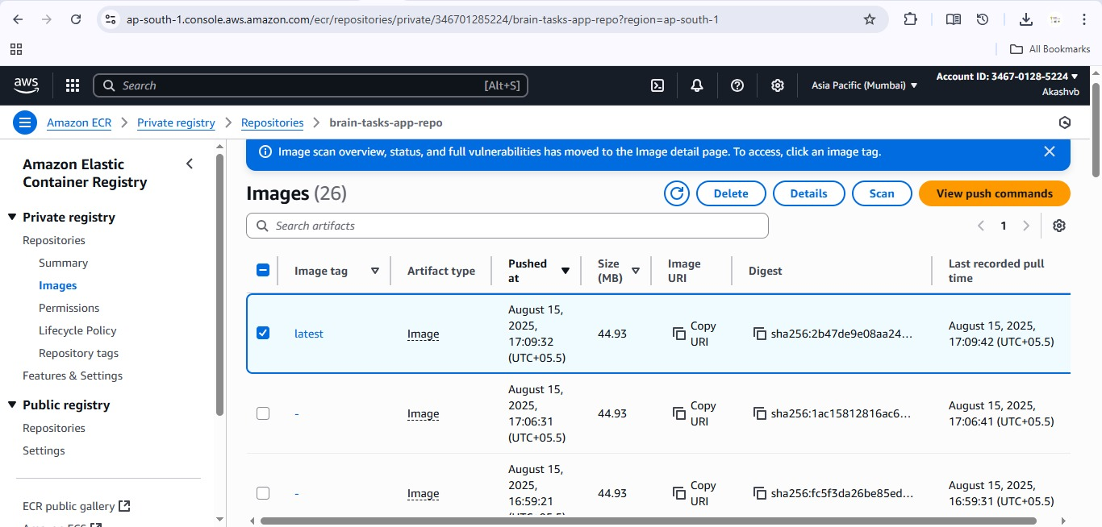

**AWS Code Build**

**Perfect! Let's go through how to set up the remaining pieces of your CI/CD pipeline in AWS:**

# **🚀 CI/CD with CodeBuild, CodeDeploy, and CodePipeline**

**This guide walks you through:**

1. **AWS CodeBuild – Build your Docker image and push to ECR**
2. **AWS CodeDeploy – Deploy your app to EKS (via appspec.yml)**
3. **AWS CodePipeline – Automate source > build > deploy steps**

## **✅ 1. CodeBuild Setup**

### **🔹 What is CodeBuild?**

**CodeBuild is a fully managed build service that compiles source code, runs tests, and builds/pushes Docker images.**

### **🔧 Required File: buildspec.yml**

**Place this in your project root:**

**version: 0.2**

**phases:**

**install:**

**runtime-versions:**

**nodejs: 14**

**pre_build:**

**commands:**

**- echo Logging in to Amazon ECR...**

**- aws ecr get-login-password | docker login --username AWS --password-stdin <your_account_id>.dkr.ecr.<region>.amazonaws.com**

**build:**

**commands:**

**- echo Build started on `date`**

**- docker build -t brain-tasks-app .**

**- docker tag brain-tasks-app:latest <your_account_id>.dkr.ecr.<region>.amazonaws.com/brain-tasks-app:latest**

**post_build:**

**commands:**

**- echo Pushing the Docker image...**

**- docker push <your_account_id>.dkr.ecr.<region>.amazonaws.com/brain-tasks-app:latest**

**artifacts:**

**files:**

**- appspec.yml**

**- deployment.yaml**

**- service.yaml**

### **🛠️ Create CodeBuild Project in Console**

* **Source: GitHub (connect to repo)**
* **Environment: Managed Image (Amazon Linux)**
* **Role: Allow access to ECR & S3 (use codebuild-role)**
* **Buildspec: Use the buildspec.yml file in repo**

**✅ Output logs will appear in CloudWatch.**

## **✅ 2. CodeDeploy Setup**

### **🔹 What is CodeDeploy?**

**CodeDeploy automates application deployments to Amazon EKS, EC2, or Lambda.**

### **🔧 Required File: appspec.yml**

**Add this in your root:**

**version: 0.0**

**Resources:**

**- myApp:**

**Type: AWS::EKS::Application**

**Properties:**

**TaskDefinition: ""**

**AppSpecContent:**

**Files:**

**- source: deployment.yaml**

**destination: /app**

**- source: service.yaml**

**destination: /app**

**Note: If deploying to EKS, this works best when integrated with Lambda or custom deployment script.**

## **✅ 3. CodePipeline Setup**

### **🔹 What is CodePipeline?**

**CodePipeline automates your full CI/CD process:**

1. **Pulls code from GitHub**
2. **Triggers CodeBuild**
3. **Deploys via CodeDeploy**

### **🛠️ Steps to Create CodePipeline:**

1. **Go to CodePipeline → Create Pipeline**
2. **Enter pipeline name: brain-tasks-pipeline**
3. **Source Stage:**
   * **Provider: GitHub**
   * **Branch: main or master**
4. **Build Stage:**
   * **Provider: AWS CodeBuild**
   * **Choose your build project**
5. **Deploy Stage:**
   * **Provider: AWS CodeDeploy**
   * **Application: brain-tasks-app**
   * **Deployment group: (select your EKS group)**

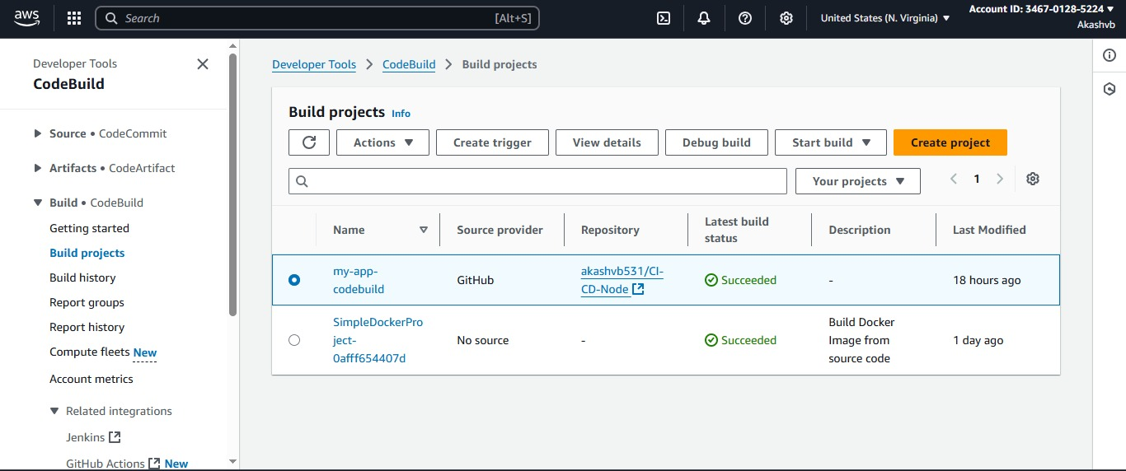

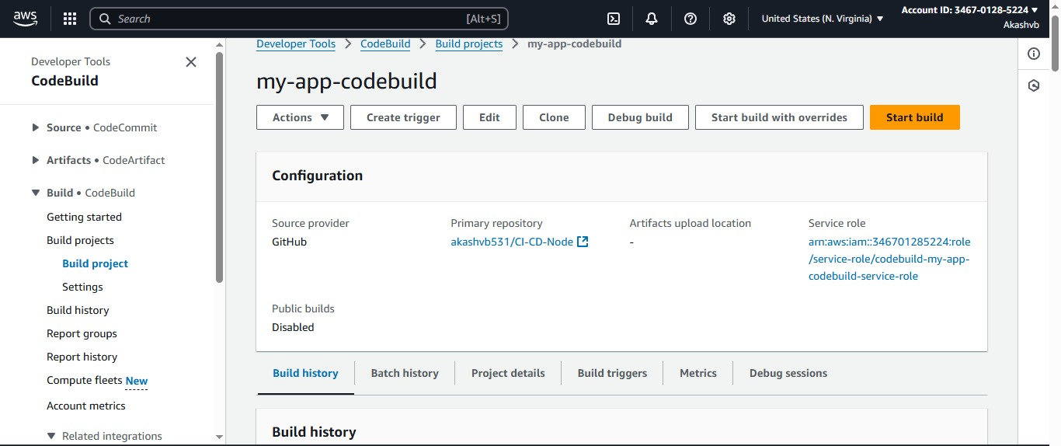

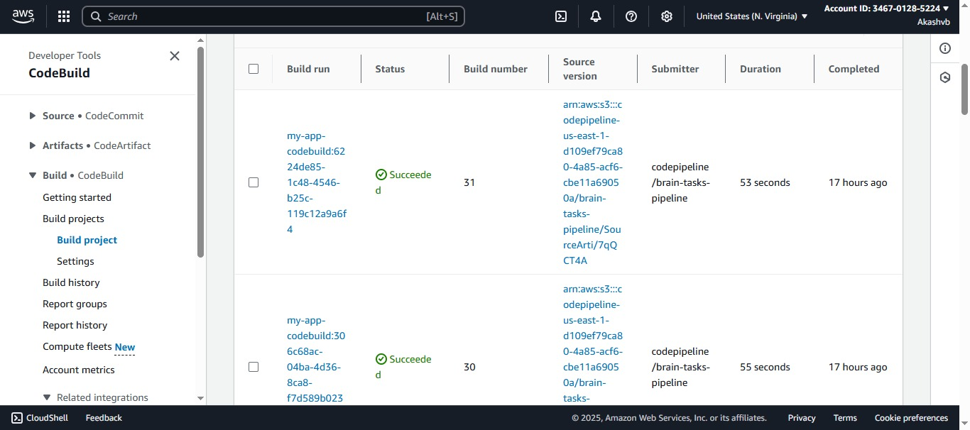

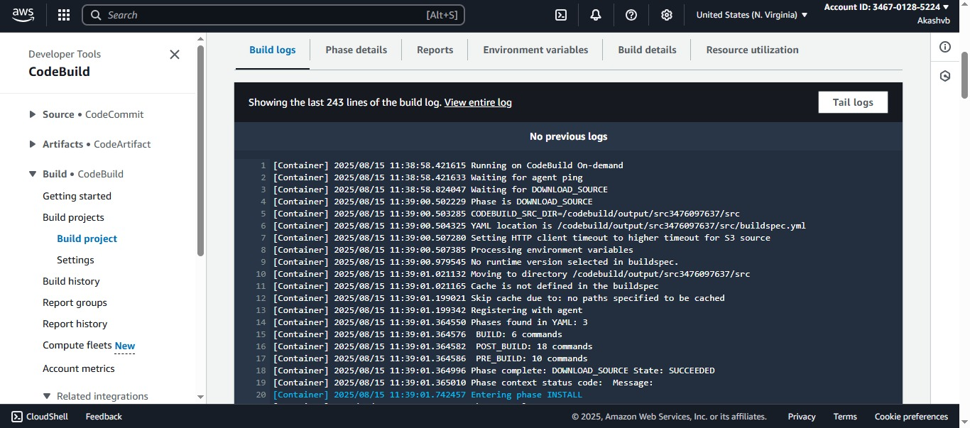

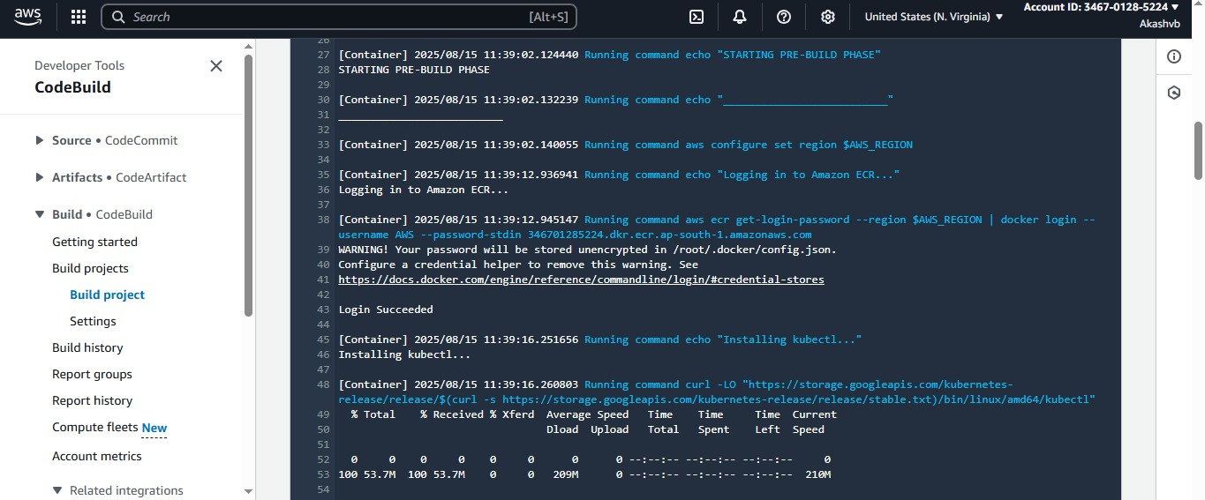



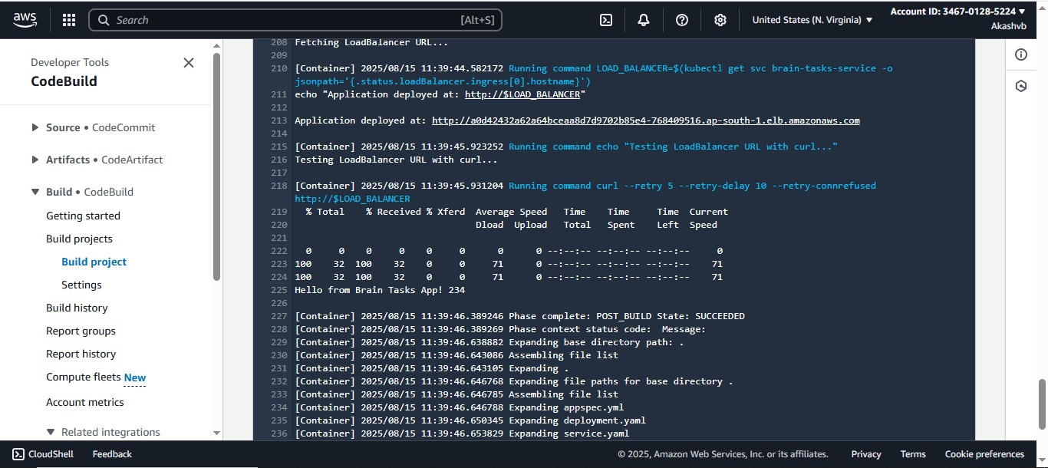

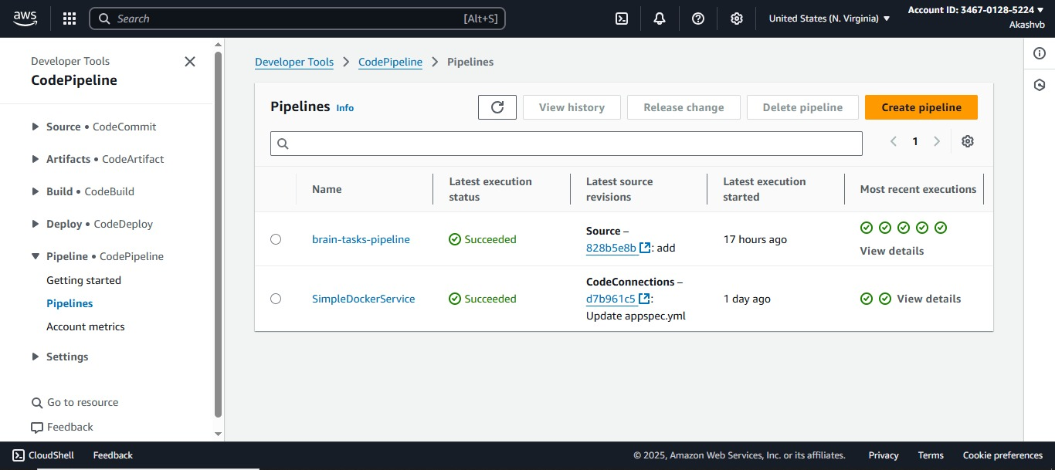

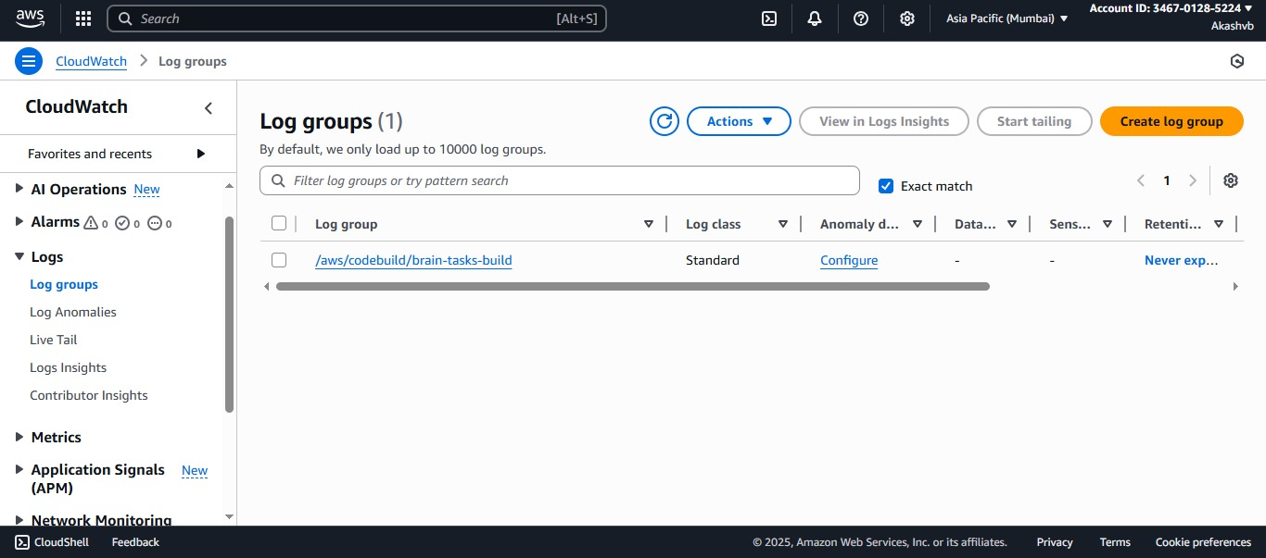

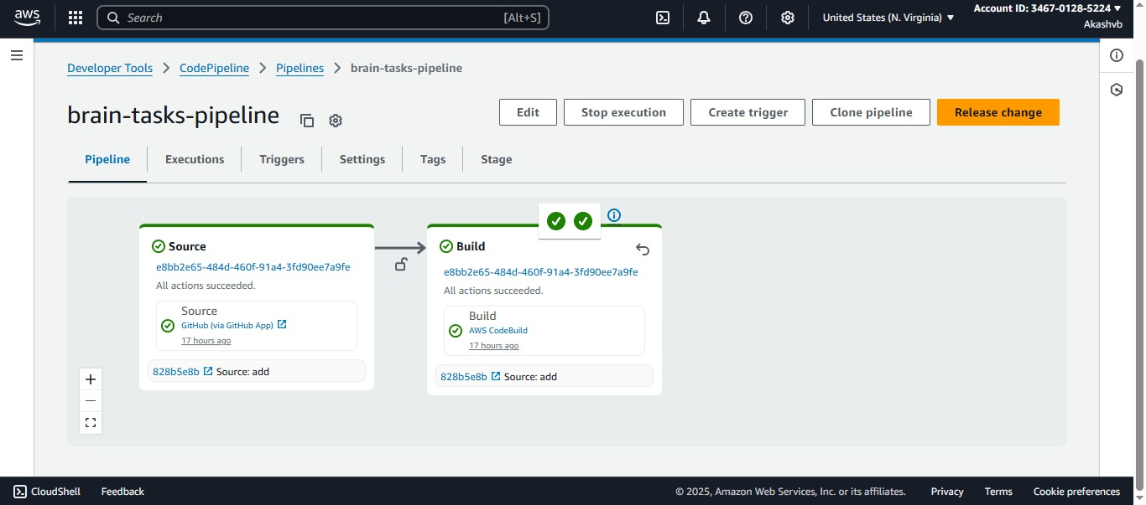

**Cloud Watch**

## **📊 Monitor Pipeline**

* **Use AWS CloudWatch to view:**
  + **Build logs**
  + **Deployment logs**
  + **Errors and success statuses**

